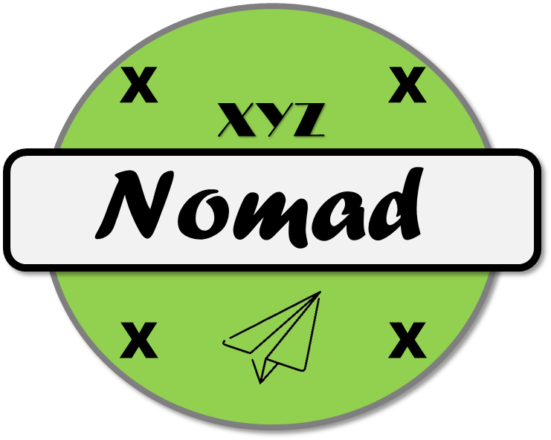

Initial Payload Testing

16 September 2019

Version 1.1



645 Colonel Glenn Blvd

Dayton, Ohio

DISCLAIMER: This document has been produced to support training and experimentation ONLY. It does not represent any system, real or planned. No United States Government resources were used to produce this document.

**THIS PAGE IS INTENTIONALLY BLANK**

Contents

1. Introduction 5

2. Flight Performance 5

1. Maximum 5

3. Control Communications 5

**THIS PAGE IS INTENTIONALLY BLANK**

1. Introduction
2. Full Motion Video

Short decription; talk about single spot ball

* 1. Test 1
     1. Pointing Accuracy
     2. Daytime Resolution

Failing Values…

* + 1. Daytime Framerate

Passes

* + 1. Pan/tilt/zoom

Passes

* + 1. Take Still Image

Passes

* 1. Test 2
     1. Nighttime Resolution

Fails

* + 1. Nightime Framerate

Passes

* + 1. Switch Between Modes

Passes

1. Payload Link
   1. Test 1
      1. Link Range

Fails, about 1.4 miles

* + 1. Data Rate

Fails, about 30 mb/s. Describe multiple attempts, including changing bands.

1. Ground Control
   1. Test 1
      1. PFD Display

Airspeed, altt, heading, roll, pitch, yaw, vert speed, lateral speed

* + 1. Maintain Position

Passes

1. Mission Control Software
   1. Test 1
      1. System Health/Status

Passes

* + 1. COP Displays Blue Force

Passes

* + 1. Display Current Route

Passes

* + 1. User Plans Route

Passes